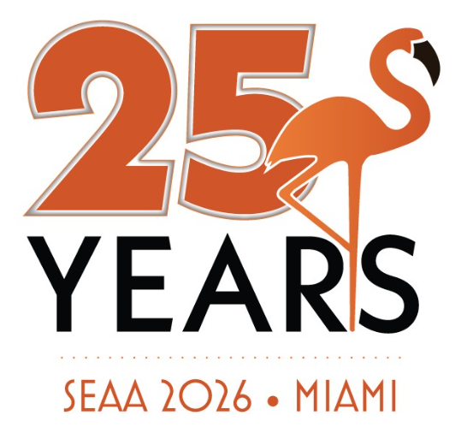
Call for Breakout Session Proposals
Proposal Submission Deadline: January 30, 2026
Southeast Acquirers Association, Inc. (SEAA) is now accepting proposals for breakout sessions to be presented at SEAA 2026, taking place on June 9, 2026, at the Fontainebleau Miami Beach.
The SEAA Advisory Committee will review all submissions and select six to eight breakout sessions for the 2026 Conference.
Session Details:
- Two breakout sessions will run concurrently during each time slot.
- Each session will last 50 minutes, including time for Q&A.
- Formats can include a single presentation, a panel discussion, or complementary presentations from multiple companies.
- Topics must be educational and focused on the electronic payments industry. Sessions may highlight a company’s product(s) but must be relevant to the industry topic.
- Proposed topics should be new and not previously presented at other industry events.
- If proposing a panel discussion, please include the names of all panelists. If selected, you will be responsible for ensuring all panelists are confirmed and available to attend on June 9, 2026.
- In cases where we receive several proposals on similar topics, we may invite applicants to collaborate in a panel discussion to provide diverse perspectives.
Important Dates:
- Proposal Submission Deadline: Friday, January 30, 2026
- Session Selections Announced: Friday, February 20, 2026
Due to limited availability, not all proposals will be selected for inclusion on the agenda. However, we are pleased to offer additional opportunities to participate through our Podcast series.
Submission Instructions:
Please complete the proposal form and return it to agenda@southeastacquirers.com by January 30, 2026.
We look forward to reviewing your submissions and seeing you at the Fontainebleau Miami Beach for our 25th anniversary of the annual SEAA Conference!
All speaker applicants must be registered as exhibitors or roaming exhibitors. For panel discussions only the applicant is required to be registered as an exhibitor; additional panelists are exempt.

PROPOSAL FOR BREAKOUT SESSION
JUNE 9, 2026

Please submit your proposal by January 30, 2026

Title of presentation and detailed description of the subject matter:

Presenter(s) identity and information – i.e., company, job title, short bio:

Why will this session be beneficial to SEAA participants:

