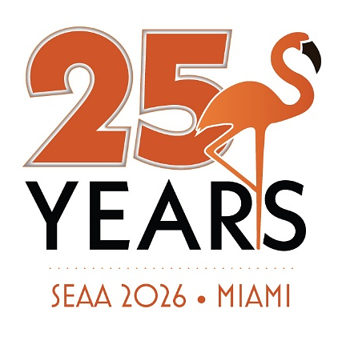

SUNDAY, JUNE 7, 2026
12:00 – 5:00 p.m. SEAA Sunday Funday
If you are arriving early to get the fun started, join the SEAA team poolside at the historic Fontainebleau

8:00 – 10:00 p.m. Welcome to Fontainebleau, Ocean Lawn
Join us on the Ocean Lawn as we kick-off the celebration for our
25th Anniversary Conference

MONDAY, JUNE 8, 2026
8:00 a.m. Registration Opens, Luster Gallerie

9:00 a -1:00 p.m. Exhibitor Set-Up, Sparkle Ballroom

1:00 – 4:30 p.m. Derek’s Dogs, Ocean Promenade East

2:00 – 4:00 p.m. Exhibit Hall Open Hours, Sparkle Ballroom

5:00 – 6:30 p.m. Opening Reception, Sparkle Ballroom

TUESDAY, JUNE 9, 2026
8:30 a.m. Registration Opens, Luster Gallerie

9:00 – 10:30 a.m. Opening Breakfast, Exhibit Hall Open Hours, Sparkle Ballroom

TBA Breakout Session, TBA, throughout the day

11:00a – 12:00 p. Opening Remarks, Keynote Presentation:
Jon Dorenbos, Fontaine/Fleur de Lis

12:00 – 1:15 p.m. Lunch

1:30 – 4:30 p.m. Breakout Sessions, TBA

4:30 – 5:30 p.m. Happy Hour, Luster Gallerie

5:30 – 7:00 p.m. Closing Reception, Sparkle Ballroom

8:00 p.m. SEAA 25th Anniversary Party, LIV Nightclub at Fontainebleau

WEDNESDAY, JUNE 10, 2026
7:00 a.m. Breakfast at your leisure, Vida

